Pass for level 10: nOpp1igQAkUzaI1GUUjzn1bFVj7xCNzu

Step 1: entering to natas 9

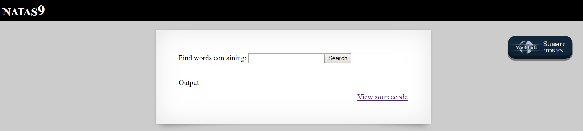

Step 2: view the source code

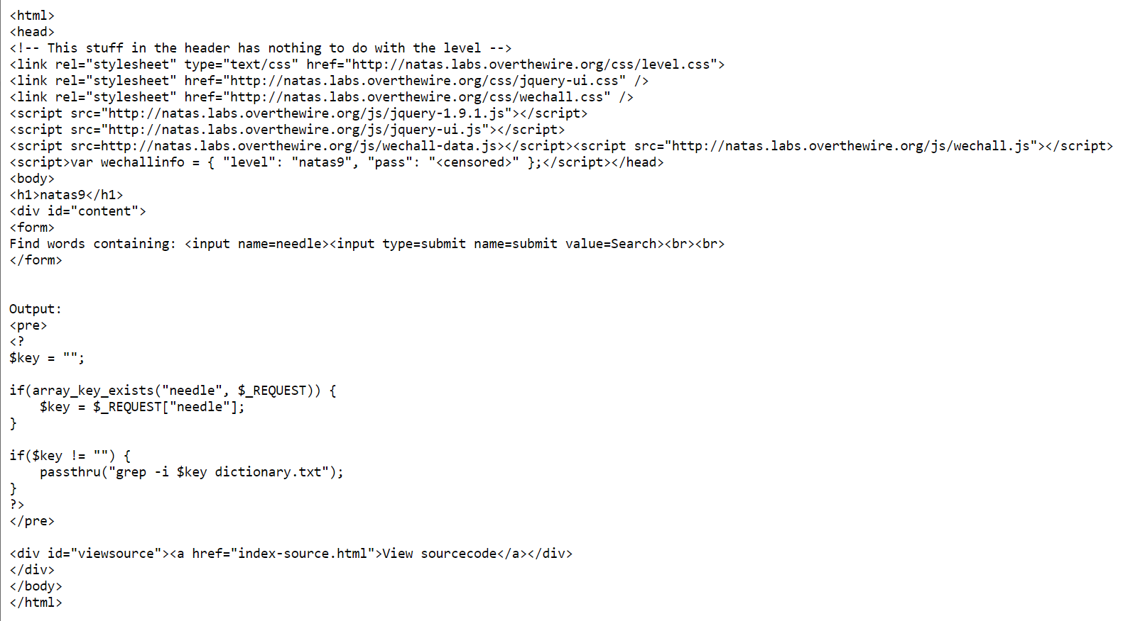

We see that the script using passthru php function that execute text as is

So we execute query like: ";cat /etc/natas_webpass/natas10"

And get:

